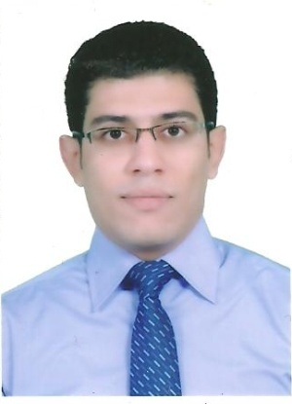
Curriculum Vitae
personal Information
Name | Mohamed Abdelrazik Salaheldin Ahmed
Title | Assistant Lecturer
Date of birth | 3-8-1984
Place of birth | Cairo
Citizenship | Egypt
Contact Information
Home phone
Work phone
Mobile phone
E-mail (s) | K84as@yahoo.com
Web site (s)
Current Address
Educational Qualifications
BSc. of veterinary medicine – Cairo University
Msc. Cytology & Histology – Cairo University
Academic Positions
Demonstrator 2008 -2011
Assistant Lecturer 2011 - Current
Thesis Title
Studies on the effect of probiotics on the structure of some organs in chicken
Areas of experience
Cytology & Histology – Image analysis – educational technology
Projects
Awards
Professional Qualifications
Conferences

Training courses
HRM diploma – Cairo University / certified Trainer – Cairo university / New trends in training and teaching techniques/ Quality assurance in teaching and training process/ Using of technology in teaching and training/ Effective presentation skills/ Business planning and administration

Computer Skills
Excellent web skills – Microsoft office package – Adobe Master Collection

Language Skills
Arabic/ English
Professional Memberships
Other activities
List of publications

Publications statistic
Journal’s Publication |  | Conference’s Publication |  | Authors |  |  | Total
Local | International | Local | International | Single | Shared |  | Total
 |  |  |  |  | Internal | External | Total

